# CRM Application to Manage the Mall

## Project Description:

The Management App is a comprehensive solution built on the Salesforce platform to streamline and enhance the management of commercial malls. This innovative app offers a suite of features designed to optimize the lease tracking process, improve tenant interactions, and provide actionable insights for effective decision-making.

## Short Description:

We're using Salesforce for the Mall Management App because it lets us build the app quickly without a lot of complicated coding. It's flexible, so we can easily customize it to fit the specific needs of managing a mall. Salesforce keeps everything organized in one place, making it easy to handle tenant info, leases, and maintenance issues. It's also secure, ensuring that sensitive data is protected

## Technical Architecture:

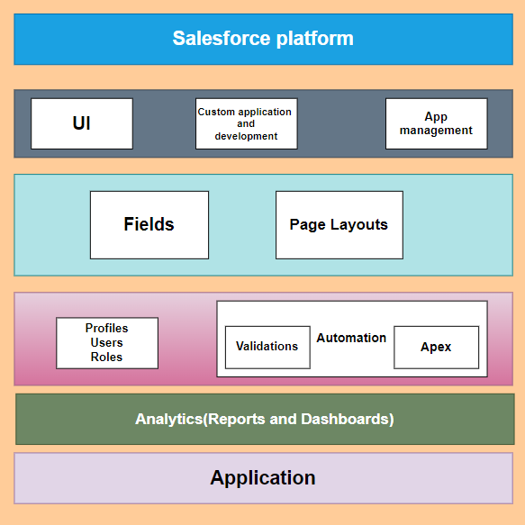

**Project Flow**

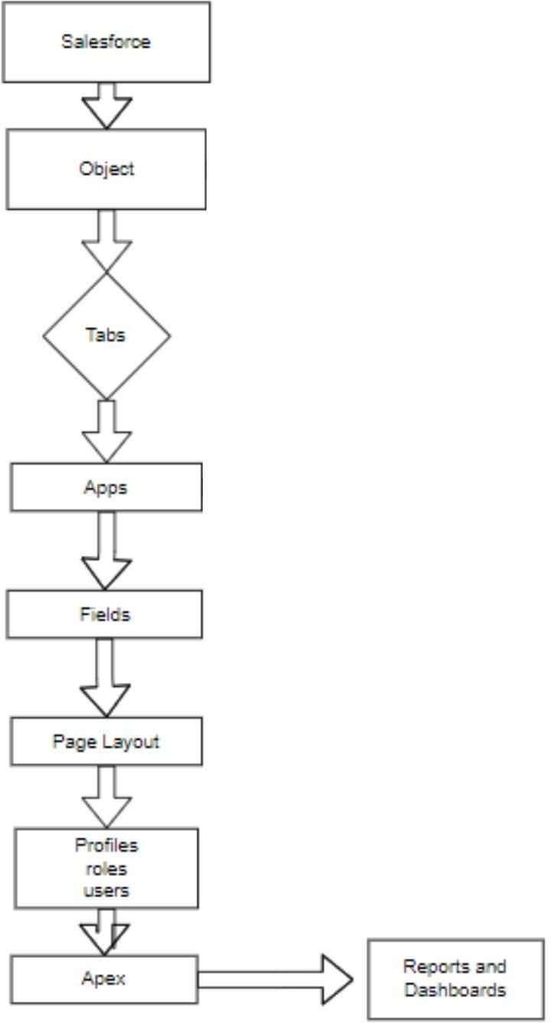

## System Requirements:

Windows 8 machine

Install with two web browser Bandwidth of 30mbps

## AGENDA:

1. Create Custom Objects
2. Tabs
3. Create Fields and Relationships
4. Create the Lightning App
5. Record Insertion
6. Create Flows
7. Apex Triggers
8. Asynchronous Apex
9. Create Reports And Dashboard

# Milestone 1-Salesforce

## Introduction:

Are you new to Salesforce? Not sure exactly what it is, or how to use it? Don’t know where you should start on your learning journey? If you’ve answered yes to any of these questions, then you’re in the right place. This module is for you.

Welcome to Salesforce! Salesforce is game-changing technology, with a host of productivity-boosting features, that will help you sell smarter and faster. As you work toward your badge for this module, we’ll take you through these features and answer the question, “What is Salesforce, anyway?”.

## What Is Salesforce?

Salesforce is your customer success platform, designed to help you sell, service, market, analyze, and connect with your customers.

Salesforce has everything you need to run your business from anywhere. Using standard products and features, you can manage relationships with prospects and customers, collaborate and engage with employees and partners, and store your data securely in the cloud.

So what does that really mean? Well, before Salesforce, your contacts, emails, follow-up tasks, and prospective deals might have been organized something like this: <https://youtu.be/r9EX3lGde5k>

## Activity 1: Creating Developer Account

Creating a developer org in salesforce.

1. Go to <https://developer.salesforce.com/signup>
2. On the sign up form, enter the following details :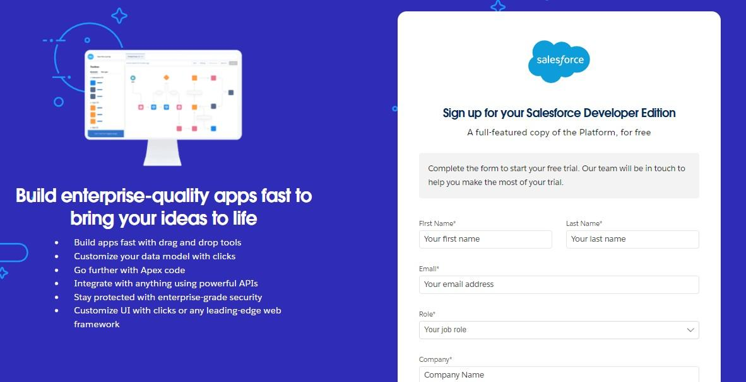
   1. County : India
   2. Postal Code : pin code
   3. Username : should be a combination of your name and company This need not be an actual email id, you can give anything in the format : [username@organization.com](mailto:username@organization.com)

Click on sign me up after filling these.

## Activity 2: Account Activation

1. Go to the inbox of the email that you used while signing up. Click on the verify account to activate your account. The email may take 5-10mins.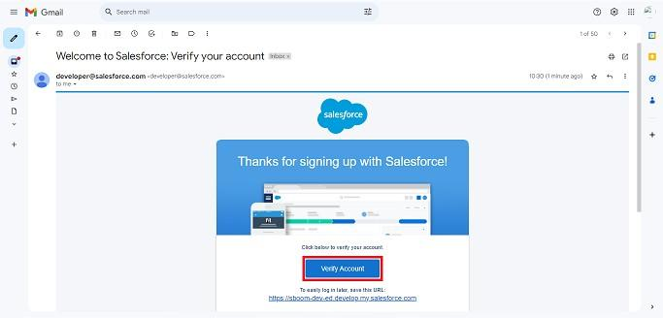
2. Click on Verify Account
3. Give a password and answer a security question and click on change password

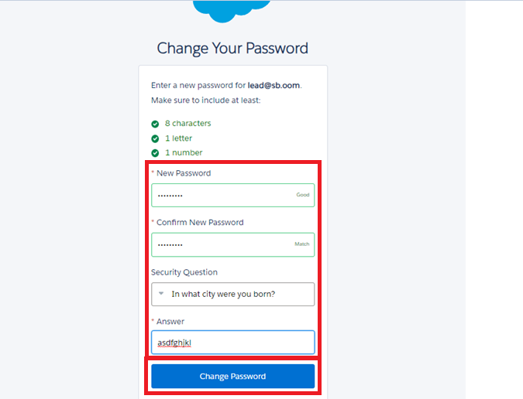

1. Then you will redirect to your salesforce setup page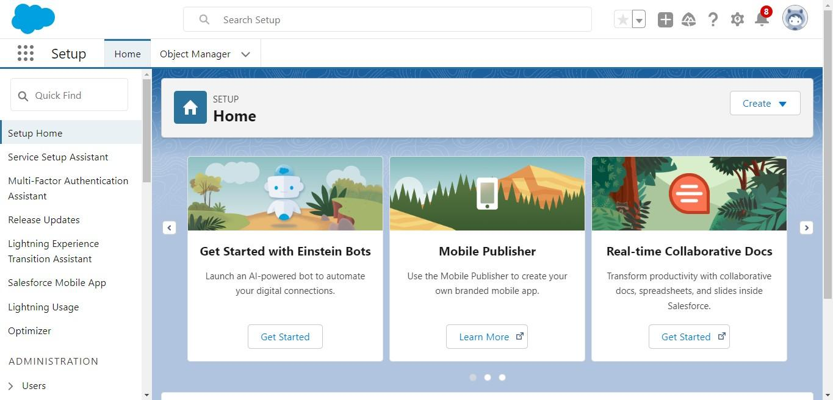

### Milestone 2- Object :

### Create Tenant Object

1. From the setup page ==> Click on Object Manager ==> Click on Create ==> Click on Custom Object.
2. Enter the label name: Tenant
3. Plural label name: Tenants
4. Enter Record Name Label and Format

* Record Name : Tenant Name
* Data Type: Text

1. Click on Allow reports.

1. Allow search and Save

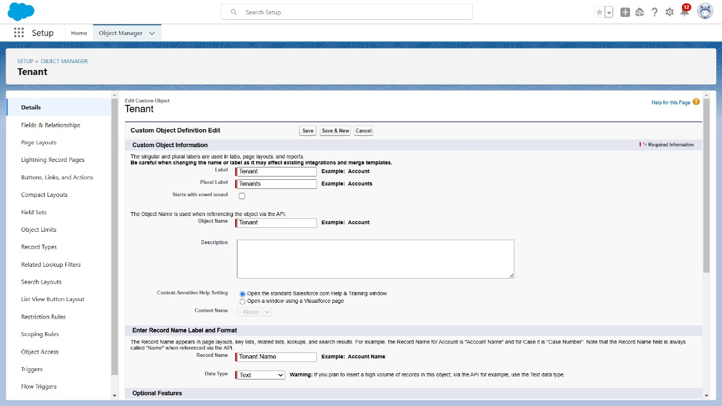

### 

### 

### 

### 

### 

### Create Lease Tracking Object

1. Enter the label name ==>Lease Tracking
2. Plural label name ==> Leases Tracking
3. Enter Record Name Label and Format

* Record Name : Lease Tracking No
* Data Type : Auto Number
* Display Format - TT - {000000}

1. Click on Allow reports.
2. Allow search and Save

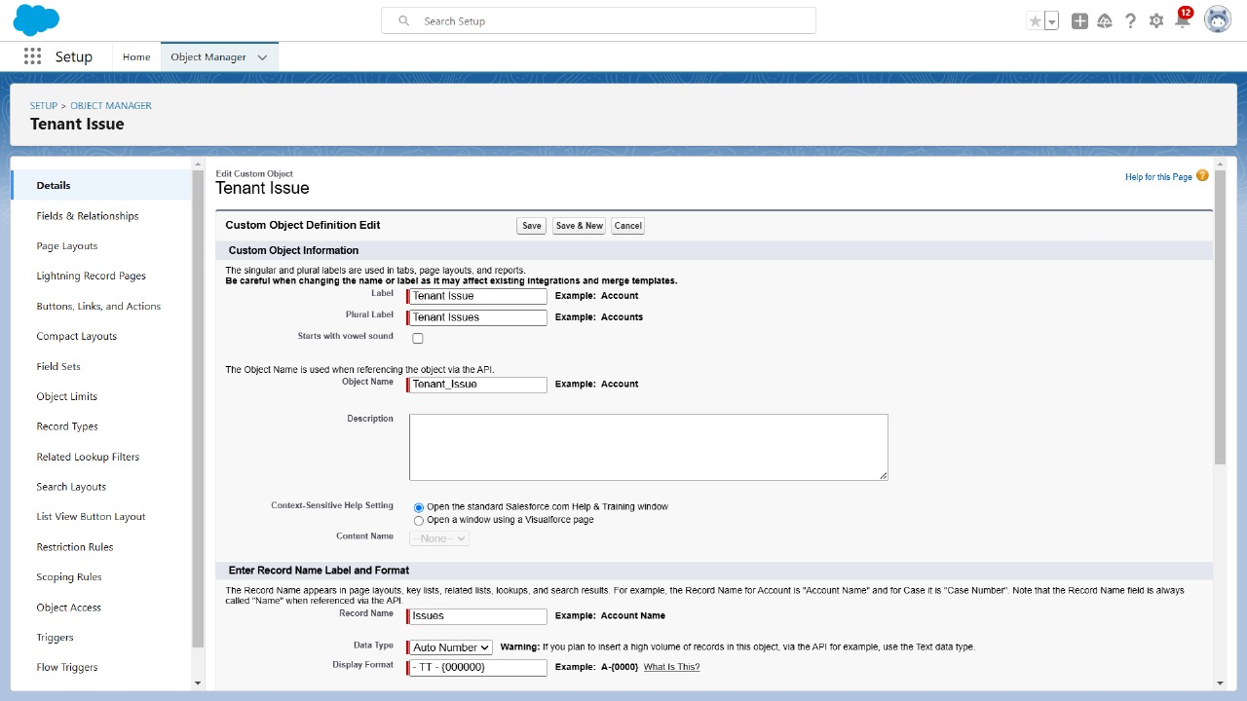

### 

### 

### 

### 

### 

### 

### Create Tenant Issues Object

1. Enter the label name ==> Tenant Issue
2. Plural label name ==> Tenant Issues
3. Enter Record Name Label and Format

* Record Name : Issues
* Data Type : Auto number

1. Click on Allow reports.
2. Allow search and Save



## 

## 

## 

## 

## 

## 

## 

## 

## Milestone 3 - Tabs

### Create a custom tab

### 1 tenant object

1. Go to setup page ==> type Tabs in Quick Find bar ?==>click on tabs ==> New (under custom object tab)
2. Select Object(Tenant) ==> Select the tab style ==> Next (Add to profiles page) keep it as default ==> Next (Add to Custom App) uncheck the include tab ==> Save.
3. Make sure to append tab to users' existing personal customizations is checked.

### 2 Lease Tracking

1. Go to setup page ==> type Tabs in Quick Find bar ?==>click on tabs ==> New (under custom object tab)
2. Select Object(lease tracking) ==> Select the tab style ==> Next (Add to profiles page) keep it as default ==> Next (Add to Custom App) uncheck the include tab ==> Save.

**3 Tenant issues**

1. Go to setup page ==> type Tabs in Quick Find bar ?==>click on tabs ==> New (under custom object tab)
2. Select Object(tenat issues) ==> Select the tab style ==> Next (Add to profiles page) keep it as default ==> Next (Add to Custom App) uncheck the include tab ==> Save.

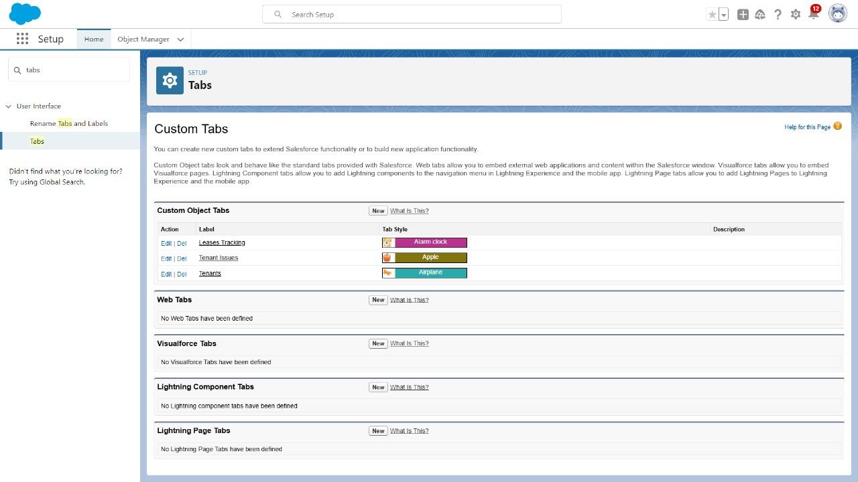

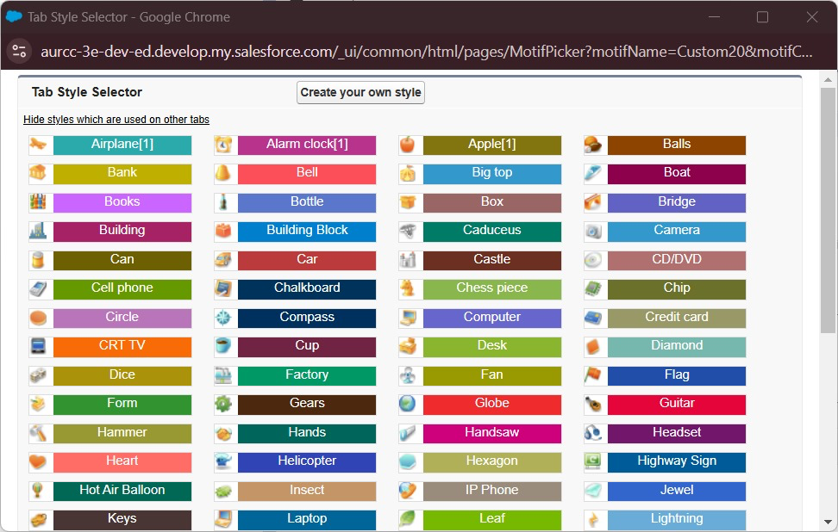

### Milestone 3 - Create Fields and Relationships:

### 1 Create Fields on Tenant object

1. While still on your salesforce account, navigate to the gear icon present in the top right corner. You will notice Setup and click on setup.
2. You will now be navigated to the setup page, and click on object manager and search for object “Tenant”.
3. Click on “Fields & Relationships” in the left panel.
4. Click on New and choose the data type Phone and first name : Phone Number.
5. Click next and fill the following details in the mentioned.
6. Click Next, Next and click on “Save and New”.

| S No | Field Label | Data Type |
| --- | --- | --- |
| 1 | Address | Text Area(255) |
| 2 | PAN Card | Text |
| 3 | Date of Reg | Date |
| 4 | Email | Email |
| 5 | GST No | Text |
| 6 | Registered License No | Text |
| 7 | Shop Act license No | Text |
| 8 | Status of possession | Pick List  Pending  Hand Overed  Renewal Needed |

### 

## Create Validation Rules for Tenant Object:

## A) Create validation rule for Phone Number :

Note:- check if the Phone Number is valid having 10 digits if not then show error.

1] Go to setup ==> click on Object Manager ==> type object name(Tenant) in quick find bar==>click on the object.

2] Click on the validation rule ==> click New.

3] Enter the Rule name as “Phone Validation “.

4] Insert the Error Condition Formula as : -

NOT(OR(REGEX( Phone_Number__c , "^[0-9]{10}")))

5] Enter the Error Message as “Enter Valid 10 digit Phone number”, select the Error location as Field and select the field as “Phone Number”, and click Save

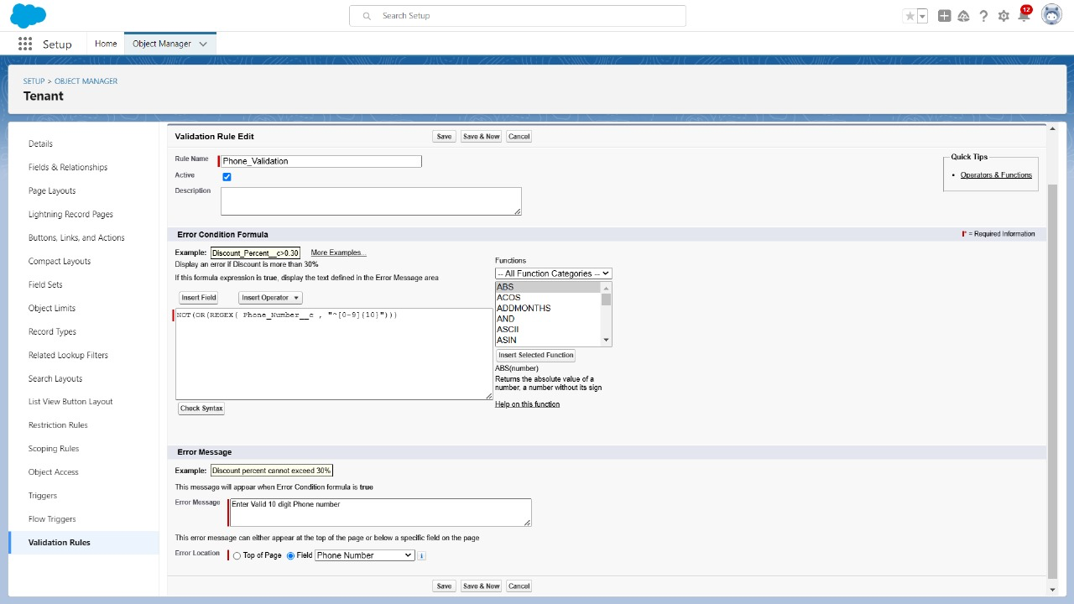

## B) Create Validation rule for Date of Reg :

Note:- check if the DateofReg is valid and is not a Date in the past.

1] Go to setup ==> click on Object Manager ==> type object name(Tenant) in quick find bar==> click on the object.

2] Click on the validation rule==> click New.

3] Enter the Rule name as “Date Validation “.

4] Insert the Error Condition Formula as : -

DateofReg__c < TODAY()

6] Enter the Error Message as “Enter Valid Date”, select the Error location as Field and select the field as “DateOfReg”, and click Save.

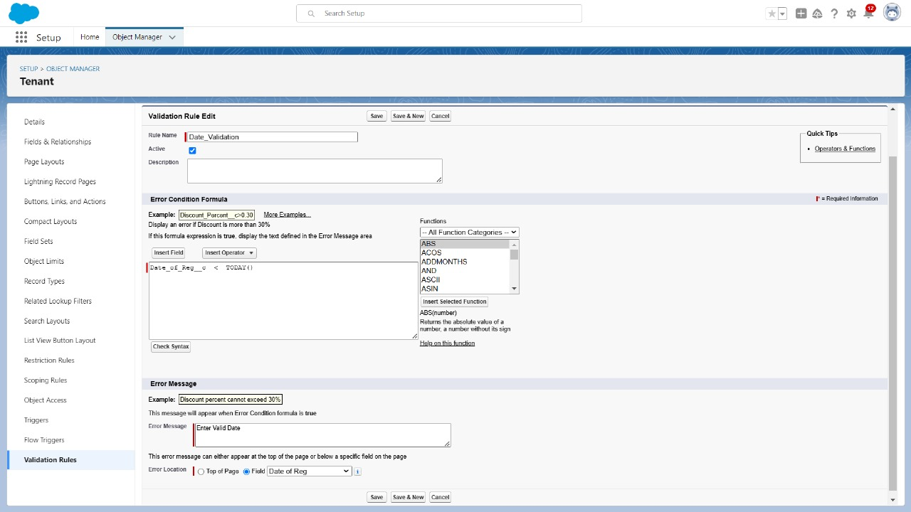

### 

### 

### 2 Create Fields on lease tracking

1. While still on your salesforce account, navigate to the gear icon present in the top right corner. You will notice Setup and click on setup.
2. You will now be navigated to the setup page, and click on object manager and search for object “Tenant”.
3. Click on “Fields & Relationships” in the left panel.
4. Click on New and choose the data type Master Detail Relationship tenant and first name : Related Tenant
5. Click next and fill the following details in the mentioned.
6. Click Next, Next and click on “Save and New”.

| S No | Field Label | Data Type |
| --- | --- | --- |
| 1 | Date of Possession | Date |
| 2 | End Date of Possession | Date |
| 3 | Total Year of Contract | Number |
| 4 | Total rent(Yearly) | Number |
| 5 | Amount Paid | Number |
| 6 | Amount to be paid | Formula field  (Total Rent - Amount Paid)  Return Data Type- Number |

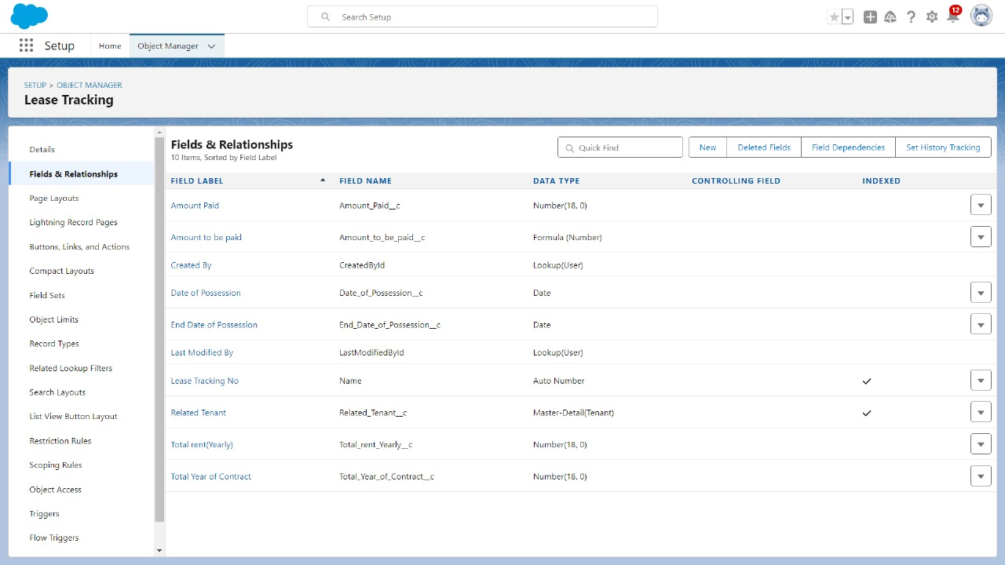

### Create Validation Rule For Lease Tracking Object :

## A) Create Validation rule on Date of Possession:

Note:- check if the Date of Possession is after 60 days from today or not if not then show error.

1] Go to setup ==> click on Object Manager ==> type object name(Lease tracking) in quick find bar==>click on the object.

2] Click on the validation rule ==> click New.

3] Enter the Rule name as “Possession Validation“.

4] Insert the Error Condition Formula as : -

Date of Possession < TODAY() + 60

5] Enter the Error Message as “Enter a date after 60 days ”, select the Error location as Field and select the field as “DateofPossession”, and click Save.

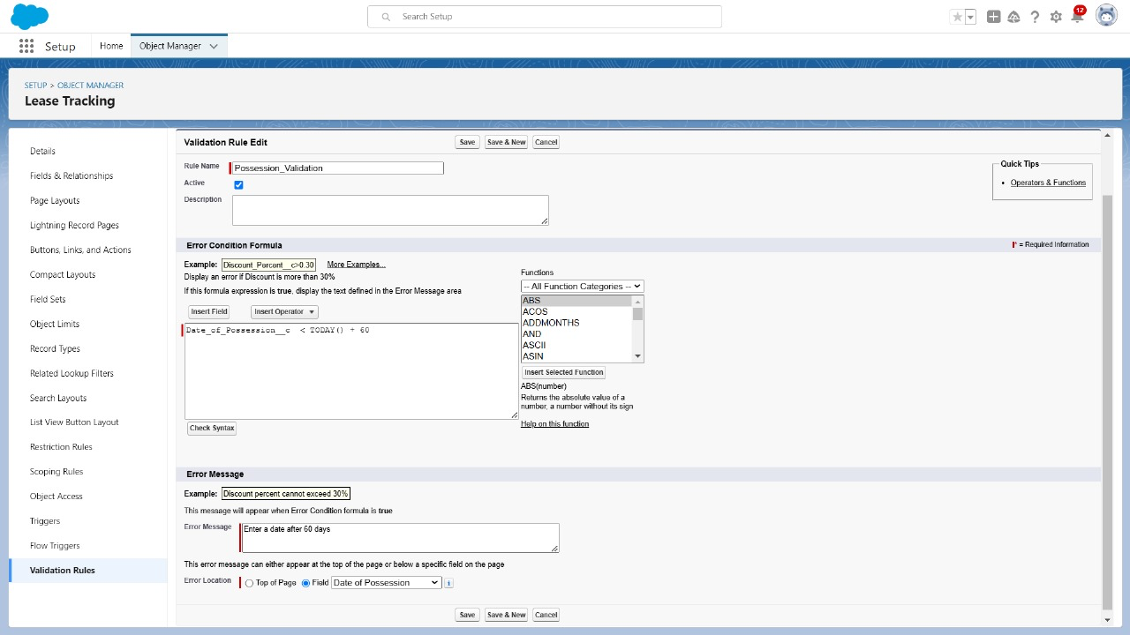

## 3 Create Fields on tenant issue:

1. While still on your salesforce account, navigate to the gear icon present in the top right corner. You will notice Setup and click on setup.
2. You will now be navigated to the setup page, and click on object manager and search for object “Tenant”.
3. Click on “Fields & Relationships” in the left panel.
4. Click on New and choose the data type Master Detail Relationship tenant and first name : Related Tenant
5. Click next and fill the following details in the mentioned.
6. Click Next, Next and click on “Save and New”.

| S No | Field Label | Data Type |
| --- | --- | --- |
| 1 | Related tenant | Master Detail Relationship  (Related to - Tenant) |
| 2 | Issue Related to | Multi Select Picklist  1) ELECTRICITY  2) INFRASTRUCTURE  3) PLUMBING  4) RENT  5) OTHER |
| 3 | Subject | Text Are (long) |
| 4 | Phone Number | Number |
| 5 | Status | Pick List     1. Not contacted 2. Open 3. In progress 4. Working 5. closed |
| 6 | Priority | Picklist     1. Low 2. Medium 3. High |
| 7 | Origin | Picklist   1. Phone 2. Mail 3. Web |
| 8 | Email id | Email |
| 9 | Date | Date  (Default Value - Today()) |

## 

### Milestone 4 -Create the Lightning App:

## create custom app in salesforce:

1. Go to setup, by clicking the gear icon present in the top right corner.
2. Navigate to the Home bar and in the quick find box, search for App.
3. Click on APP MANAGER.
4. You can notice the screen like this. Now click on New Lightning App.You will find like this below.
5. Enter the App name( Here we entered ‘SmartMall’),the developer name gets automatically populated. If an image is required, you can browse the image and upload it.

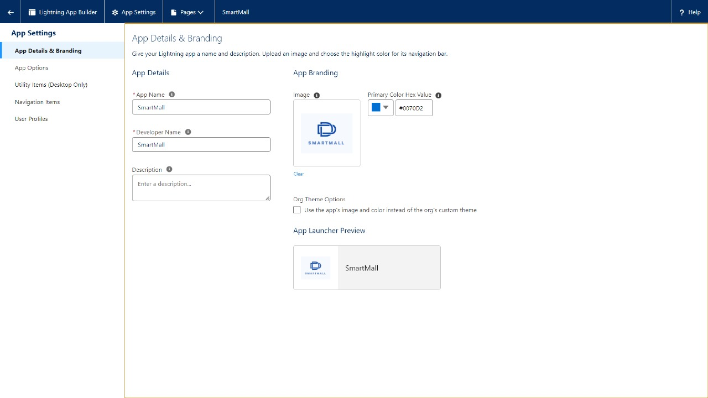

1. Click Next, Next and you can see a Navigation Items window like this:
2. In the filter list, enter Tenant , Lease Tracking, Tenant issues and move them in the Selected items from Available items.

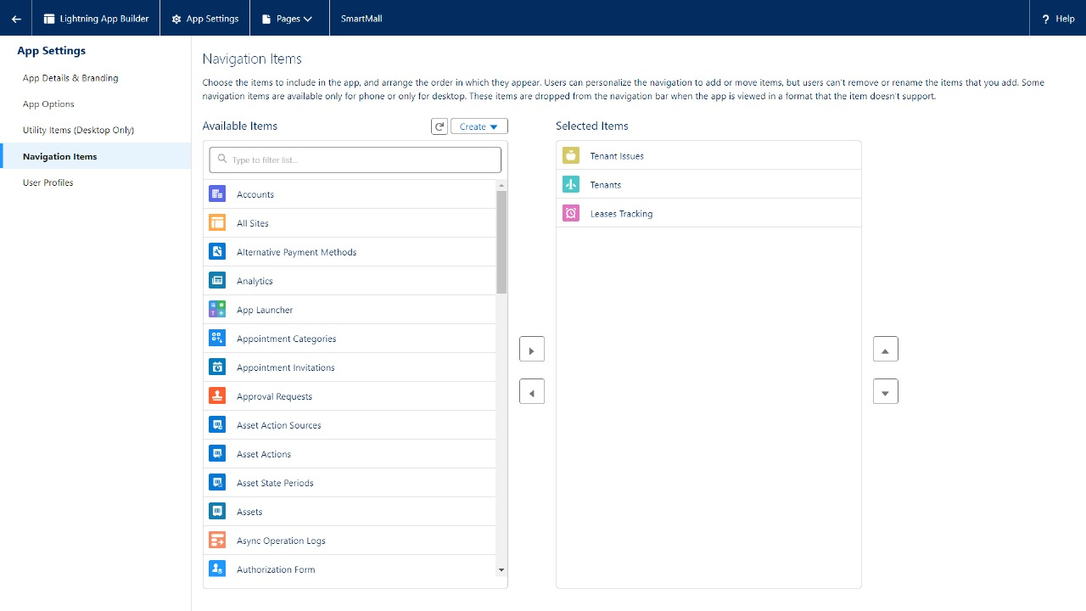

1. Click on Next , and you can see User Profiles. This option is used when we want only certain profiles to access them.
2. Enter System Administrator in the filter box and add the system Administrator to the selected profile list.

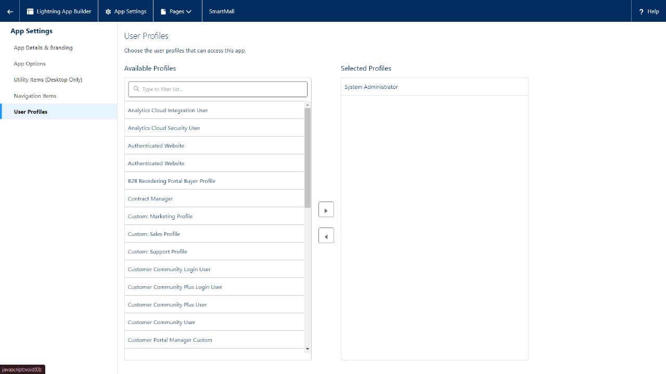

1. Click on Save and Finish.
2. Now navigate to the App launcher and search for SmartMall and you can find the SmartMall app.

### Milestone 5 - Record Insertion:

Creating records in Salesforce is a fundamental and essential activity that serves multiple purposes, contributing to the effective management of data, streamlined processes, and overall success of an organization.

## Inserting Records in Tenant Object:

1) Click on the App Launcher and search Tenant Object then click New in the right corner to create a record.

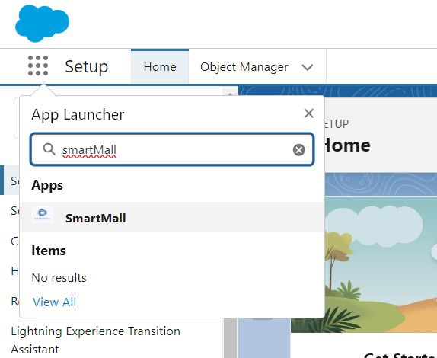

2) Fill every field with valid data, especially the fields on which you have created a validation rule.

3) If you Enter Phone Number more or less than 10 digits it will show an error.

4) Similarly, if you enter DateofReg a Past date it will show an error.

5) After creating a record the page will look like this

[ Note]: Create at least 10 records in the tenant object.

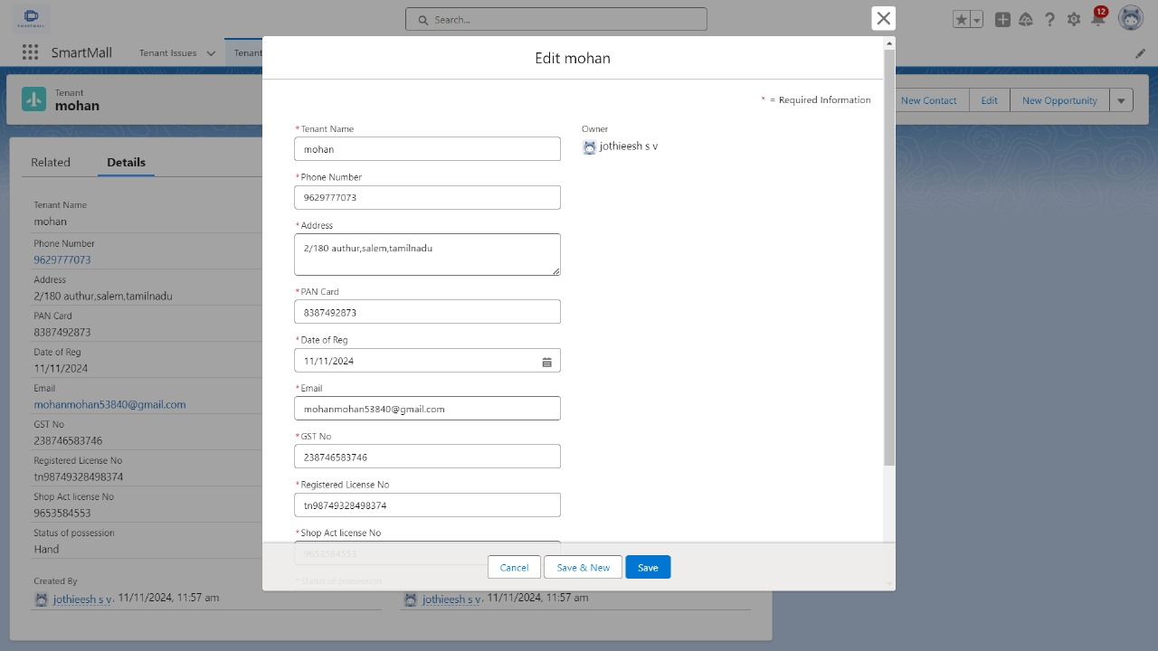

## Inserting Records in Lease Tracking Object:

1) Click on the App Launcher and search Lease Tracking Object then click New in the right corner to create a record.

2) Fill every field with valid data, especially the fields on which you have created a validation rule and Give each tenant related to each lease tracking.

3) If you Enter Date before the next 60 days it will show an error.

4) Similarly, if you enter Total rent and Amount Paid the Amount to be paid formula field will be added directly.

5) After creating a record the page will look like this

[ Note]: Create at least 10 records in the Lease Tracking object.

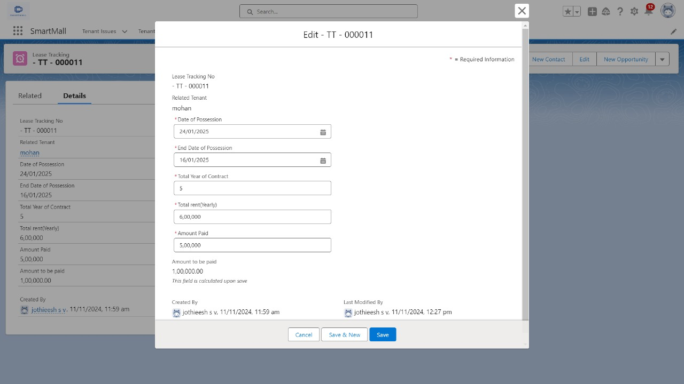

## Inserting Records in Tenants Issues object:

1) Click on the App Launcher and search Tenant Issues Object then click New in the right corner to create a record.

2) Fill every field with valid data.

3) Give each tenant related to each issue.

5) After creating a record the page will look like this

[Note]: Create at least 10 records in the tenants issues object.

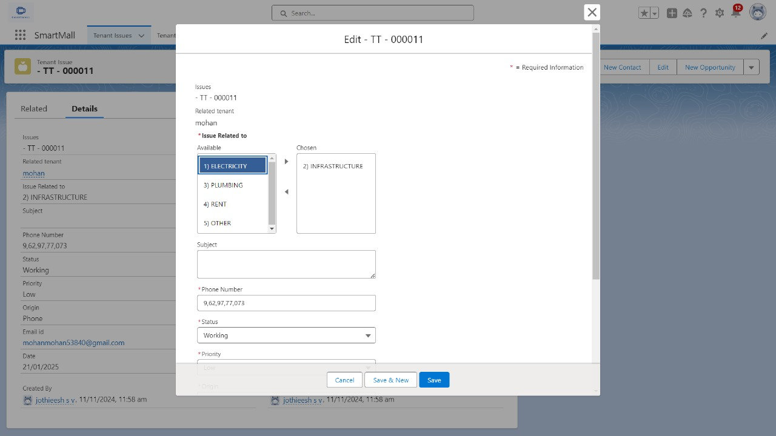

### Milestone 6 - Create Flows:

In Salesforce, a Flow is a powerful tool that allows users to automate complex business processes by orchestrating and automating sequences of tasks, data manipulations, and user interactions. Flows are designed through a visual interface, making them accessible to users with varying technical expertise.

### Create a Record Triggered flow on tenant Object

Whenever tenant record is created and the GST No field in tenant Object is empty a mail should be sent to the tenant requesting the GST No.

1) To create a flow click on setup==> Flow ==> Click on New Flow==> Select Record Triggered Flow

2) In Trigger the flow when Select A record is created

3) Select Condition required All Conditions are met (AND

4) Select Field - GST_No__c , Operator - Is Null , Value - True.

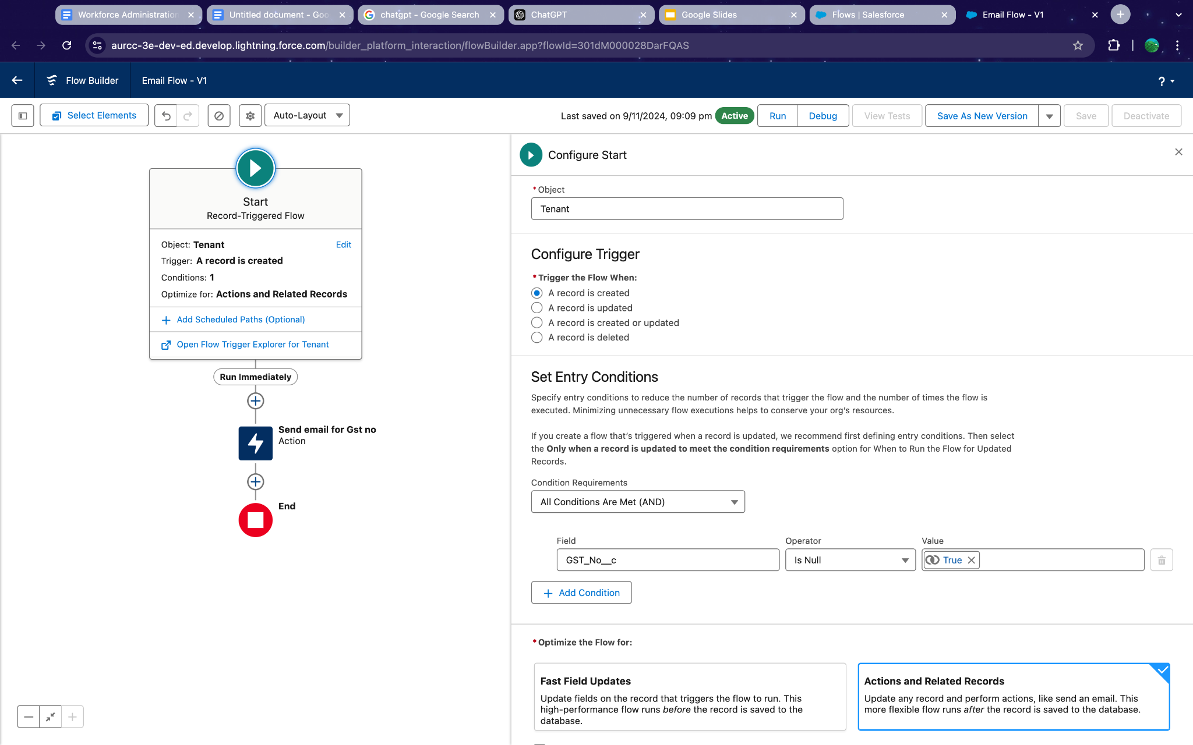

5) Optimize the Flow for: Actions and Related Records

6)Add Element and choose ACTION in the search bar Search Send Email.

7) Label Name - Send email for Gst no, Description - This email is to alert the tenant that he or she has not submitted the GST NO yet.

8) Include Body And Create a Resource - Text Template As below-

9) Include Recipient ID and from profile select tenant Email id.

10) Include Subject and enter - Regarding your GST Details

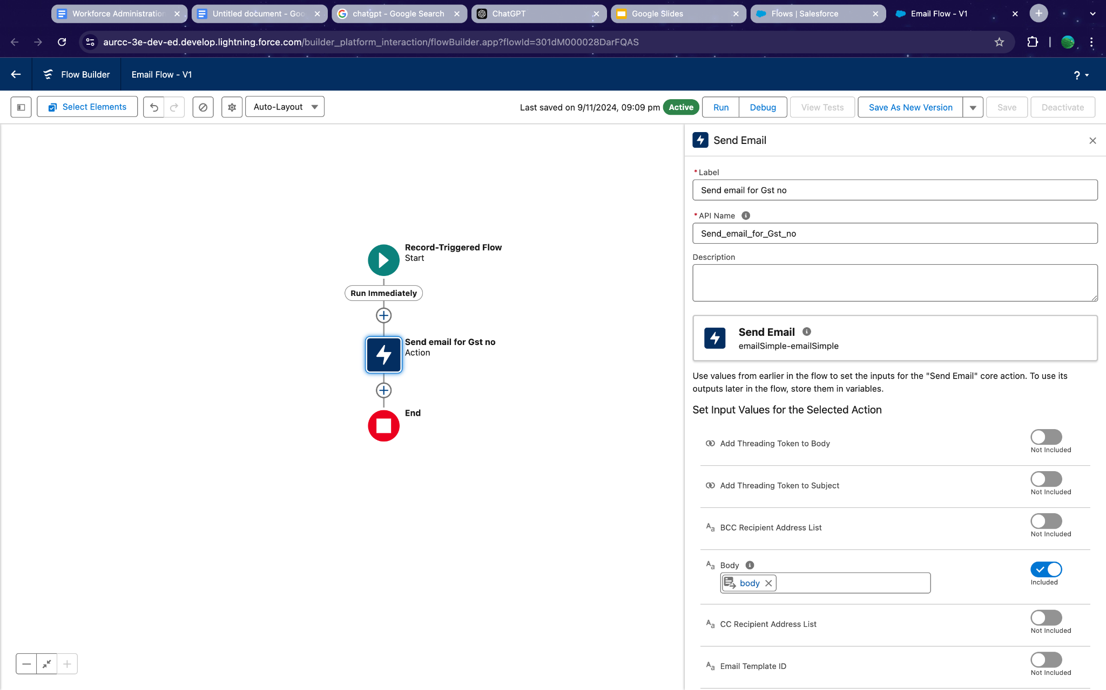

11) Click on Save and Name the Flow as Email Flow for tenant and Save.

12) Activate the flow.

### Create a Schedule Flow on Lease Management Object:

If the End Date is within Next 1 year create a task to the Lease tracking weekly on every Monday.

1) To create a flow click on setup ==> Flow ==> Click on New Flow==> Select Schedule-Triggered Flow

2) Set the Schedule Date - Any Monday , Time - 11.30, Frequency - Weekly.

3) Choose Object as Lease Tracking , Condition Requirements - All Conditions are met(AND)

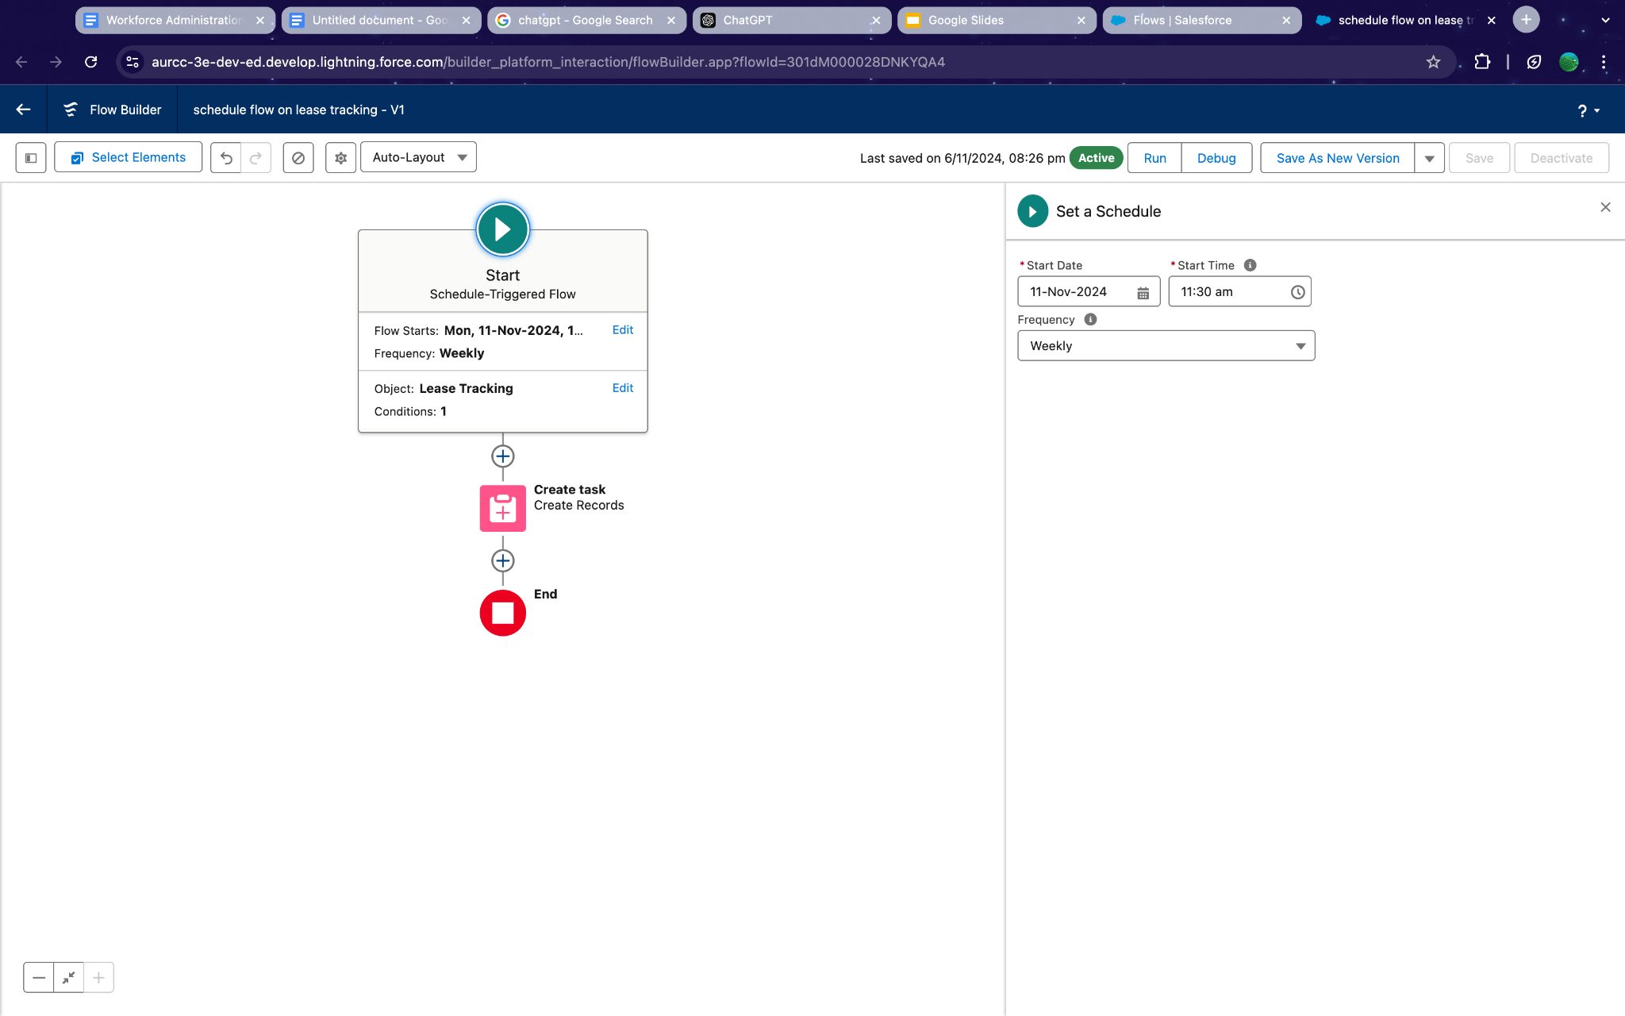

4) Enter field as End_Date_of_Possession__c

5) Operator - Less than

6) Value - 1/1/2024

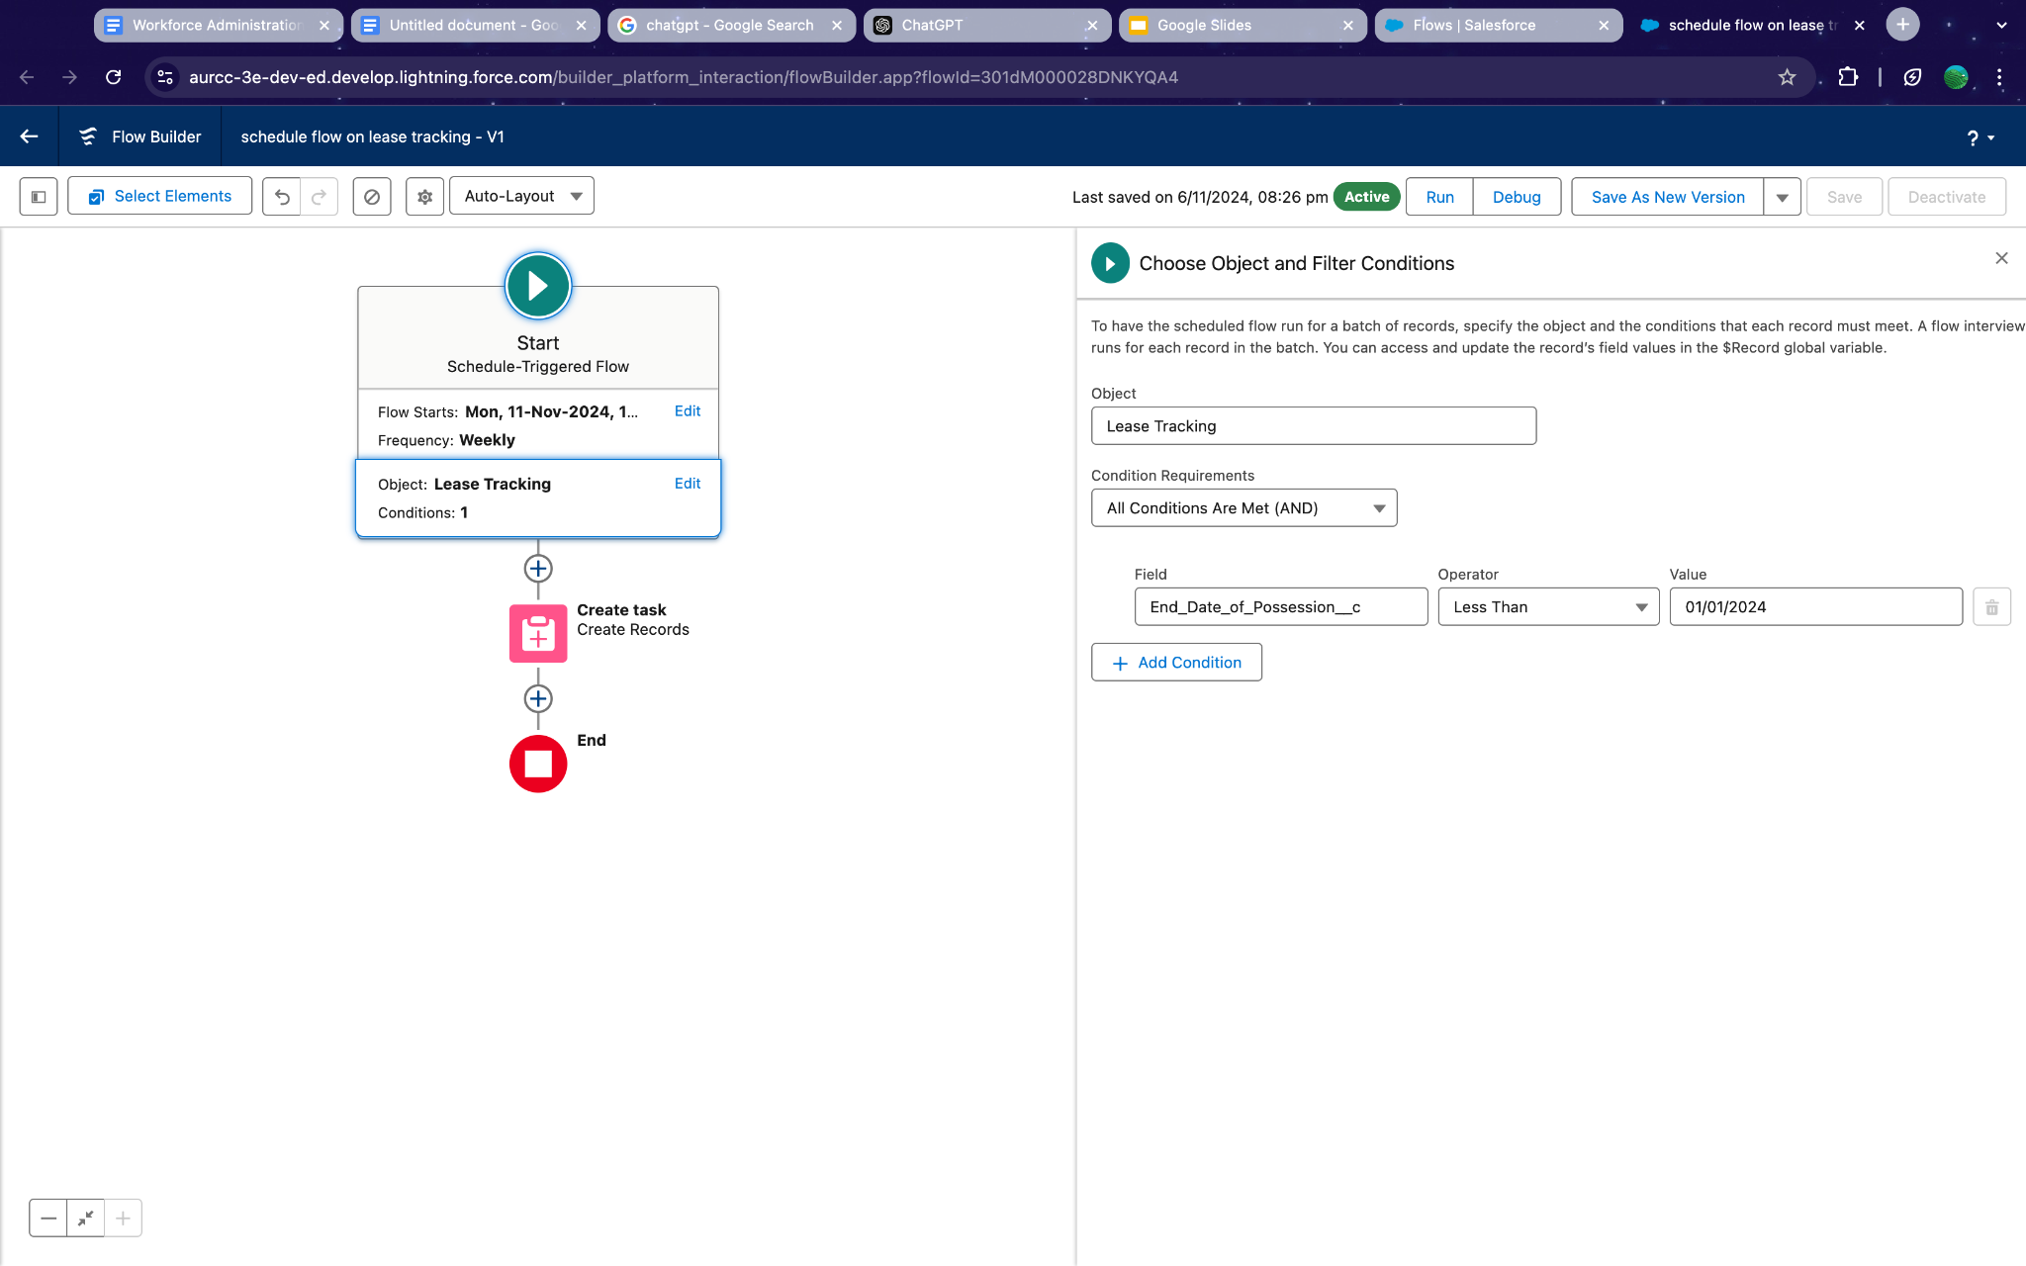

7) Create a Record give labe as Create task

8) How many Records to create - one

9) How to Set the Record Fields - Use Separate Values

10) object - Task

11) Select the field and map them as below : -

12) Subject of the Task - your possession is going to end soon. Please Contact with Manager to renew your Possession or to End the contract.



13) Save the flow and label it as ‘ schedule flow on lease tracking’

14) Activate the flow.

### Milestone 7 - Apex Triggers:

A trigger is a set of Apex code that runs before or after DML(Data Manipulation Language) events.

A DML event could be a variety of data processing tasks that include the standard insert, update, and delete commands.

With Apex triggers, you can automate tasks that would otherwise be nearly impossible to accomplish using only the Salesforce user interface. Triggers enable you to create custom scripts that you can implement according to your needs, and the only limitation is your coding skills.

There are two Salesforce Apex trigger types:

Before triggers. These are helpful in cases that require a validation process before accepting a change. They run before any database changes. After triggers. These are helpful in cases where you need to modify your database records and when the necessary value is stored in other records. They run after any database changes. Both types will help you perform custom tasks and manage records effectively. They can help you perform bulk actions as they can handle several records simultaneously.

How to create a new trigger :

1. While still in the trailhead account, navigate to the gear icon in the top right corner.
2. Click on developer console and you will be navigated to a new console window.
3. Click on the File menu in the toolbar, and click on new Tigger.

Enter the trigger name and the object to be triggered.

### Write an Apex Trigger to send an email if the tenant has not paid 50 Percent of Total Rent.

1) Click on the gear icon and click on the developer console.

2) Click on file select New Apex Trigger

3) Name- leasetrackingtrigger, Object —> Lease_Tracking__c

4) Use Event - After insert and After Update and Use Trigger Context Variables as IsAfter and IsUpdate.

#### Trigger : -

##### CODE SNIPPET :

trigger leasetrackingtrigger on Lease_Tracking__c (After insert,After update) {

if(Trigger.isAfter && Trigger.IsUpdate)

{

LeaseTrackingTriggerHandler.method1(trigger.old);

}

}

##### 

##### 

##### 

##### 

##### Trigger Handler : -

1) Create an apex class and Name it LeaseTrackingTriggerHandler

##### CODE SNIPPET : -

public class LeaseTrackingTriggerHandler {

public static void method1(List<Lease_Tracking__c> lt1)

{

for(Lease_Tracking__c lt2: lt1 )

{

if(lt2.Amount_to_be_paid__c > (lt2.Total_rent_Yearly__c)/2)

{

Messaging.SingleEmailMessage M = New Messaging.SingleEmailMessage();

List<String> ToADD = New List<String>{lt2.Email_id__c};

M.setToAddresses(ToADD);

M.setSubject('Regarding the Pending Rent');

M.setPlainTextBody('Hello, This is an Reminder for you to complete your due rent by the end this month, your due rent thatneeds to be paid is' +lt2.Amount_to_be_paid__c);

List<Messaging.Email> AB = New List<Messaging.Email>{};

AB.add(M);

Messaging.sendEmail(AB);

}

}

}

### Write an Apex Trigger on Tenant Object to Show error if the pan card is invalid.

1) Click on the gear icon and click on the developer console.

2) Click on file select New Apex Trigger

3) Name- TenantTrigger, Object - Tenant

4) Use Events - Before insert and Trigger context Variable - IsBefore

#### Trigger : -

##### CODE SNIPPET : -

trigger TenantTrigger on Tenant__c (before insert) {

if(Trigger.isBefore)

{

TenantTriggerhandler.method1(Trigger.New);

}

}

#### Trigger Handler : -

1) Create an apex class and Name it TenantTriggerhandler

##### CODE SNIPPET: -

public class TenantTriggerhandler {

public static void method1(List<Tenant__c> te)

{

for(Tenant__c tenant : te)

{

if(tenant.Pan_Card_no__c.length() > 10)

{

tenant.addError('This Pan Card number is invalid, Please Enter Valid Pan Card number');

}

}

}

}

## Milestone 8 - Asynchronous Apex:

Asynchronous Apex in Salesforce refers to a programming paradigm where code execution is detached from the immediate context and occurs independently, typically in the background. This approach is designed to handle long-running processes, heavy computations, or tasks that should not block user interactions.

### Schedule Apex

Delete the Tenant Records Monthly whose Status Of Possession is closed.

1) Create a class with name tenantschedulable

2) Give extension Schedulable to the class.

3) Open the Anonymous Window.

4) Schedule the class-

tenantschedulable a = new tenantschedulable();

string cron = '0 0 0 1 * ? * ';

system.schedule('Delete the records monthly', cron, a);

##### CODE SNIPPET : -

public class tenantschedulable implements Schedulable

{

public void execute(Schedulablecontext sc)

{

list<Tenant__c> ten = [SELECT Id, Status_of_Possession__c FROM Tenant__c ];

list<Tenant__c> tenantstodelete = New List<Tenant__c>();

for(Tenant__c te: ten)

{

if(te.Status_of_Possession__c == 'Closed')

{

tenantstodelete.add(te);

}

}

Delete tenantstodelete;

}

}

## Milestone 9 - Create Reports And Dashboards:

Salesforce Reports and Dashboards are powerful tools that empower users to visualize and analyze data within the Salesforce platform. They play a crucial role in providing insights, monitoring performance, and making informed business decisions.

### 1 lease Management Records

The Manager needs a report which shows the tenant and their joining date and their Remaining payment details and also group this by date of Registration, and make a bucket list of remaining amount as greater than 1000000 as red, less than 1000 and greater than 500000 as blue and less than equal to 500000 as yellow.

1) Create a new Folder and name it as MallReports

2) Click On new report ==> Select object Activities with LeaseTracking ==> Click on start report

3) Click on the Amount to be paid column and click on bucket this list and name it as Remaining amount

4) Save the report named as lease report and Save it in MallReports.

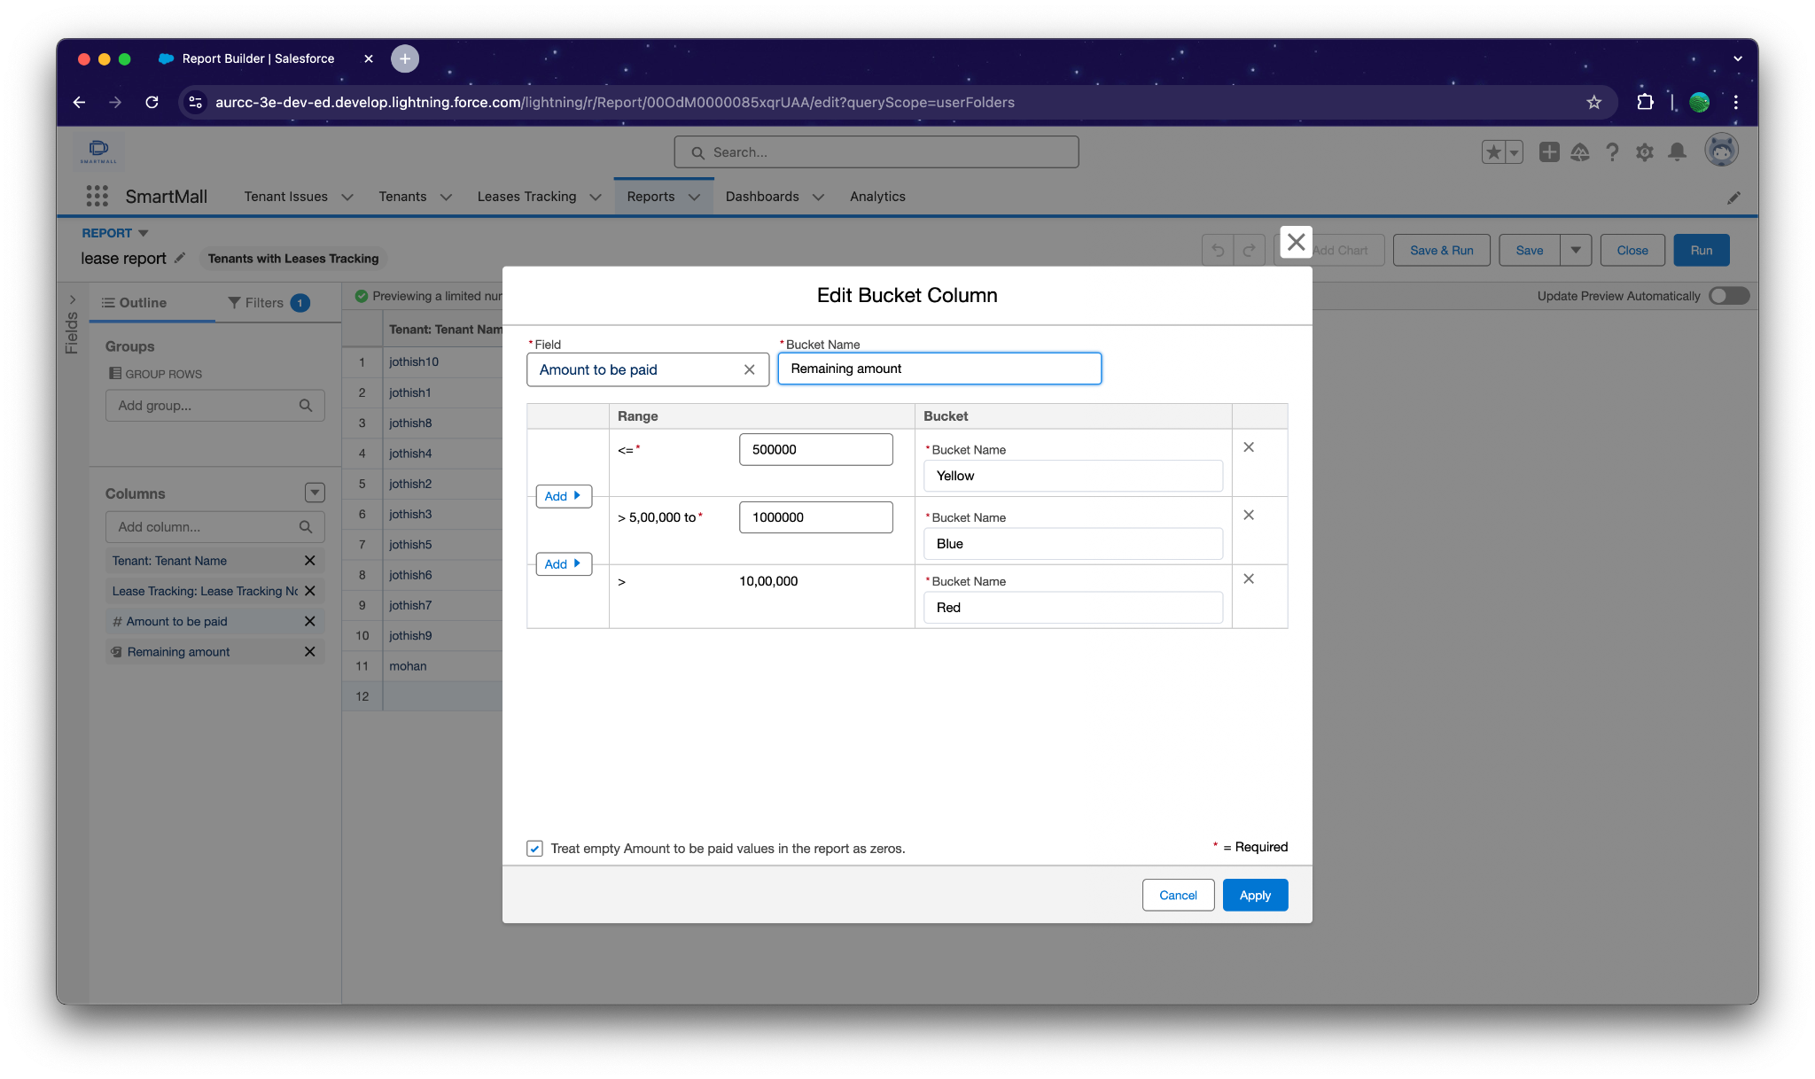

### 2 Tenant issue Records

Now the manager is asking for a report on issues which has not been contacted or Open yet and has high priority which are directly encountered by Phone and Mail and the date of issue is from last 7 days

1) Click On new report ==> Select object Activities with Tenant issue==> Click on start report

2) Click on save, enter Name - Issue Report

3) Choose the folder Mall Reports and save.

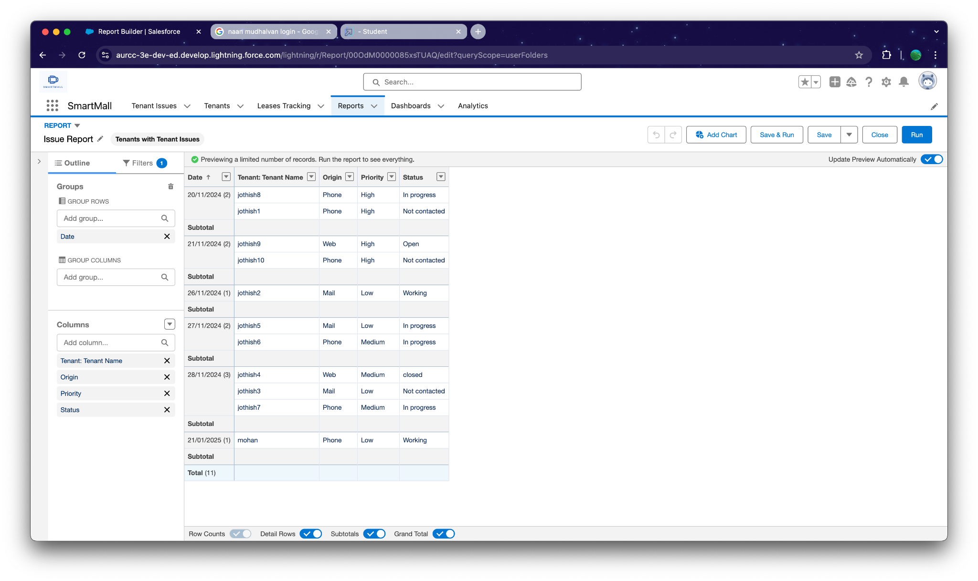

### 3 Tenant Records

Now, The Manager wants a Report which shows all the pending possessions and also shows the tenant’s Pan Card no and GST NO and group date of reg by column and row by Status of Possession.

1) Click On new report ==> Select object Tenants ==> Click on start report

2) Choose the folder Mall Reports.

3) Save the report and Name it as Tenant Details.

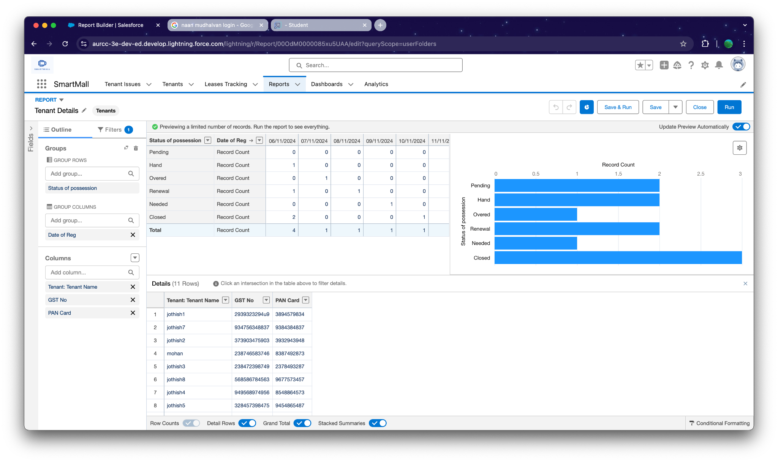

### Create a Dashboard

Very Good, You have created multiple reports but now for better convenience the owner wants a Dashboard which shows the data of these reports, So Create a Dashboard and follow the instruction below -

1) To Create a Dashboard first create a folder to store the dashboard and save it as Mall Dashboard.

2) Now click on New Dashboard

3) Enter Name - December Dashboard, select the Mall Dashboard folder and click on create.

4) Click on + Component and Select Tenant Details, Display as Horizontal Bar Chart,

Dimensions - Height * width = 10*12.

5) Click on + Component and Select Issue Report, Display as Lightning Table,

Dimensions - Height * width = 8*6.

6) Click on + Component and Select lease report, Display as Lightning Table,

Dimensions - Height * width = 8*6

7) Click on save and Done.

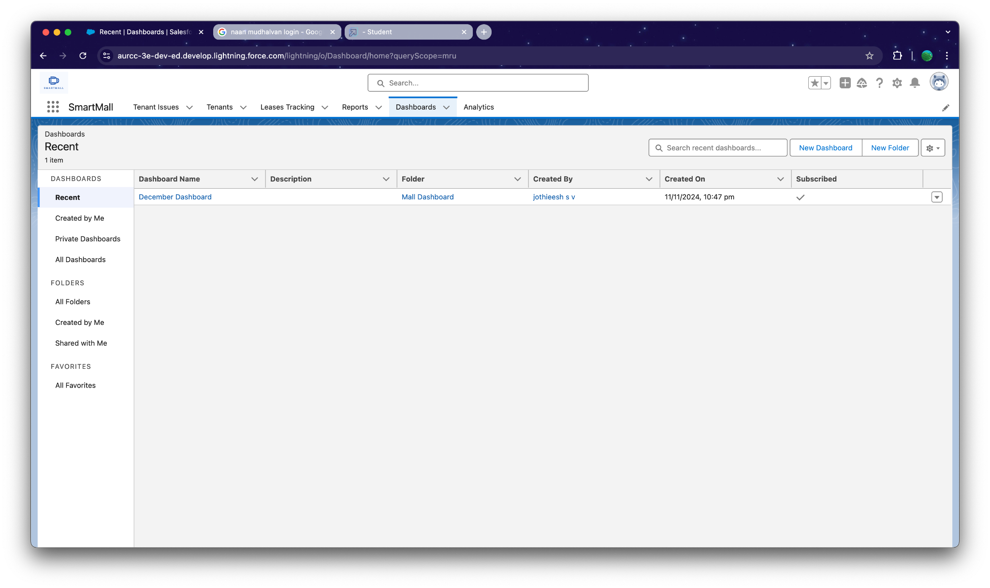

### Tenant Records

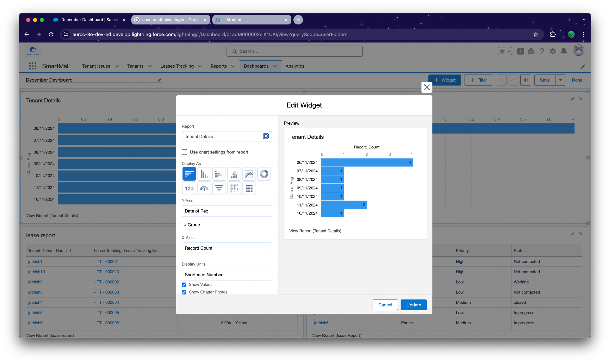

### 

### 

### 

### Lease Report

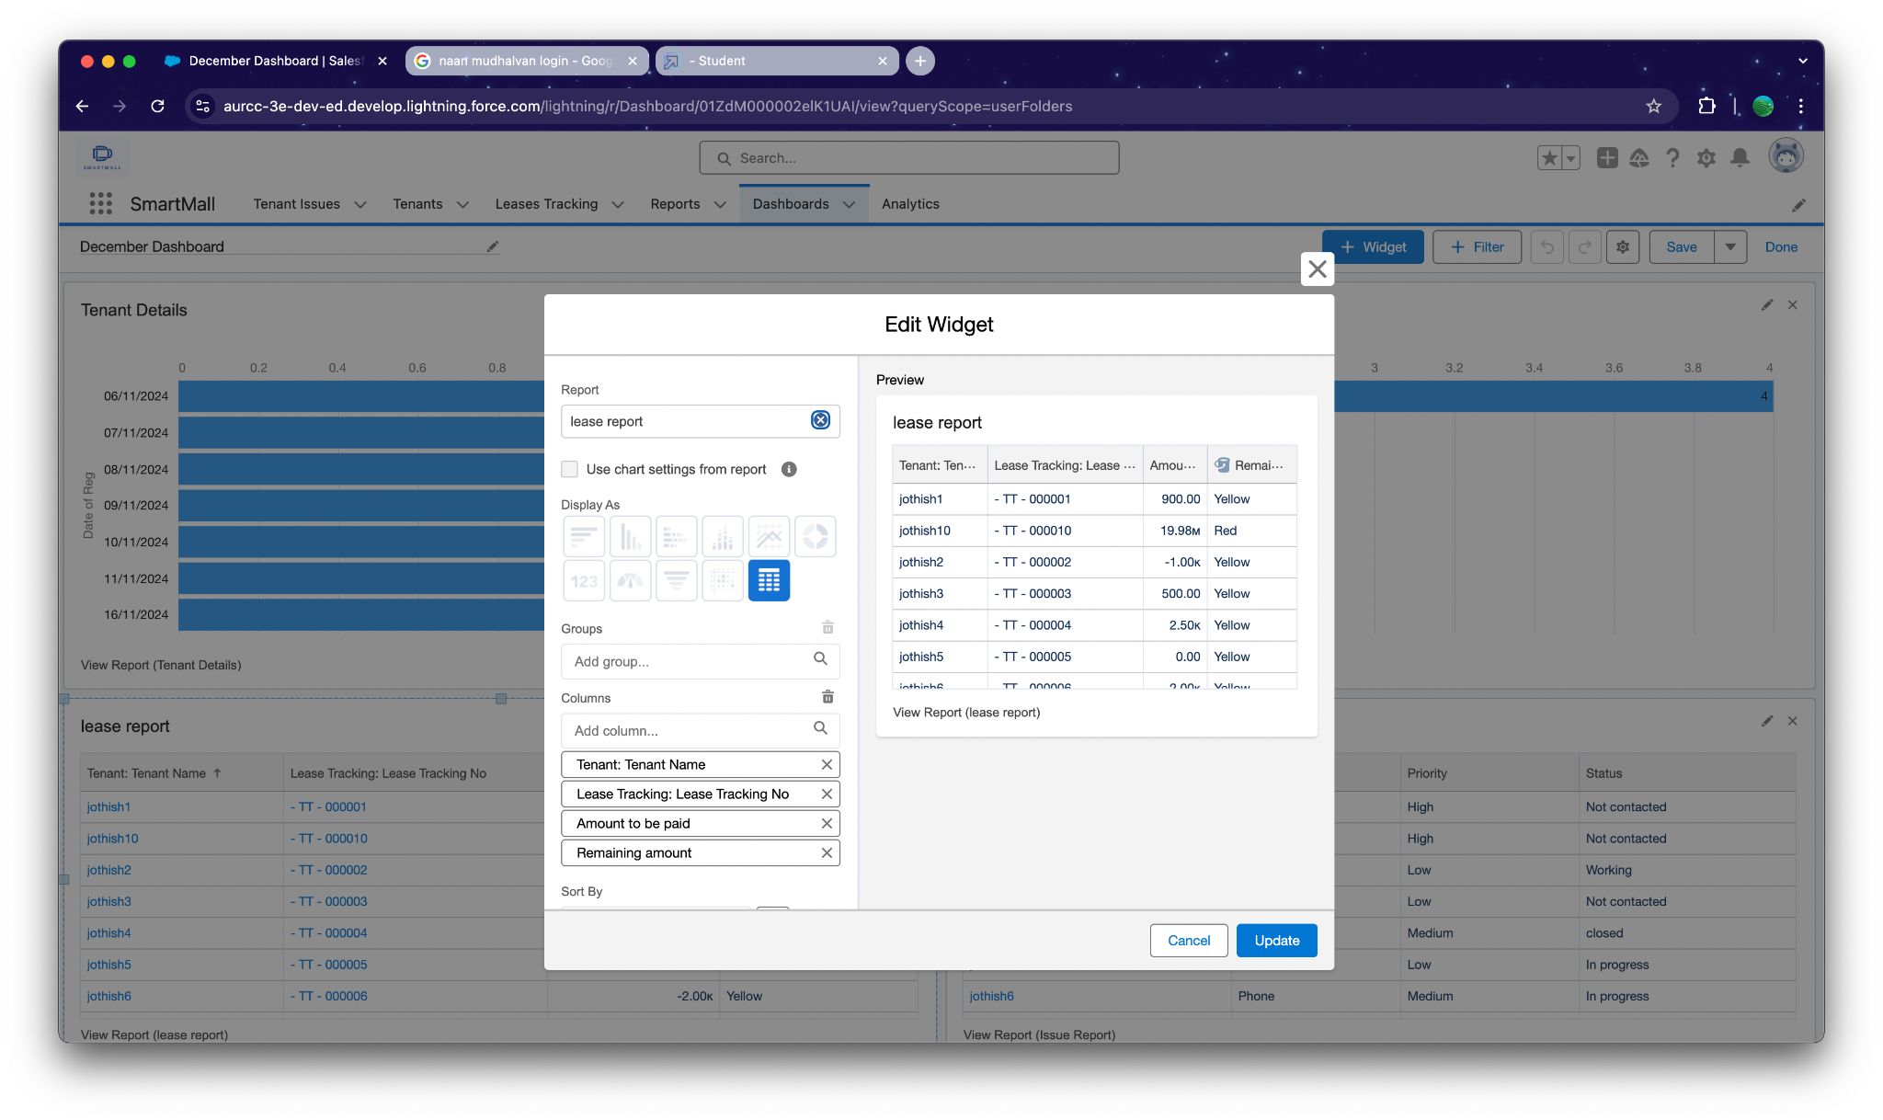

### Issue Report

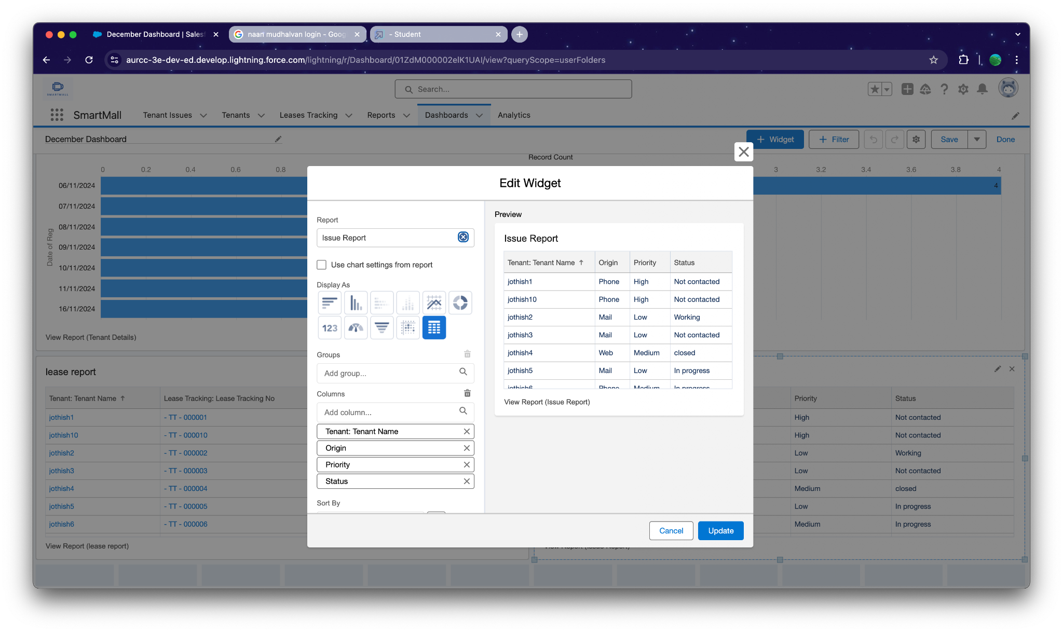

**December Dashboard**

